Week 1: Financial Planning Workbook
Introduction to Financial Planning
Content
- Definition and importance of financial planning in business.
- Key components of financial planning: budgeting, cash flow management, and investment planning.
Section 1: Understanding Your Financial Health
Questions/Exercises:
- Assess Your Current Financial Situation
  - What is your current monthly revenue?
  - List your primary monthly expenses (rent, salaries, utilities, etc.).
  - How much debt does your business currently have?
Exercise
- Create a simple balance sheet for your business.
Section 2: Budgeting Basics
Content
- Introduction to budgeting.
- Types of budgets: operating, capital, cash flow.
Questions/Exercises:
- Creating Your First Budget
  - Based on your current financials, draft a basic monthly operating budget.
  - Identify areas where you can potentially reduce costs.
Section 3: Cash Flow Management
Content
- Understanding cash flow.
- Difference between profits and cash flow.
Questions/Exercises:
- Cash Flow Analysis
  - Calculate your business's cash flow for the past three months.
  - Identify any cash flow challenges and brainstorm potential solutions.
Section 4: Setting Financial Goals
Content
- Importance of setting financial goals.
- Short-term vs long-term financial goals.
Questions/Exercises:
- Defining Your Financial Goals
  - List at least two short-term financial goals (next 6-12 months).
  - List at least one long-term financial goal (next 3-5 years).
Section 5: Investment Planning
Content
- Basics of investment planning for small businesses.
- Risk and return considerations.
Questions/Exercises:
- Evaluating Investment Opportunities
  - Are there any areas in your business that require investment for growth?
  - What are the potential risks and returns of this investment?
Section 6: Reflective Questions
- How confident do you feel about managing your business’s finances?
- What are the key areas you need more help with in terms of financial planning?
Conclusion
- Summary of key takeaways from Week 1.
- Encouragement to apply the learned principles in their business.
Additional Resources
- List of recommended readings, online courses, or tools for further learning in financial planning.

This workbook can be provided in a digital format (like a PDF) or as a physical copy. Ensure that it's interactive and allows space for the participants to write down their answers and reflections. The goal is to provide a structured approach to understanding and improving their financial planning.

Week 2: Analytics & Assessment Workbook
Introduction to Analytics and Assessment
Content
- Understanding the role of analytics and assessment in business success.
- How to use data to inform decision-making and strategy.
Section 1: The Basics of Business Analytics
Content
- Definition and importance of business analytics.
- Types of analytics: descriptive, diagnostic, predictive, prescriptive.
Questions/Exercises:
- Identifying Your Current Analytics Practices
  - What types of data does your business currently collect?
  - How do you currently use this data in decision-making?
Section 2: Establishing Key Performance Indicators (KPIs)
Content
- What are KPIs and why are they important?
- How to select the right KPIs for your business.
Questions/Exercises:
- Selecting KPIs Relevant to Your Business
  - Based on your business goals, list potential KPIs that could be important for tracking progress.
  - Choose at least three KPIs you believe are most critical for your business right now.
Section 3: Measuring Success
Content
- Defining success in your business context.
- Aligning KPIs with business goals.
KPI Examples:
- Revenue Growth: Measures the increase in a company's sales or revenue over a specific period.
- Net Profit Margin: The percentage of revenue remaining after all expenses, taxes, and costs have been deducted.
- Gross Profit Margin: Measures the percentage of revenue that exceeds the cost of goods sold.
- Operating Cash Flow: Tracks the cash generated or used by the company's core business operations.
- Customer Acquisition Cost (CAC): The cost associated with acquiring a new customer.
- Customer Lifetime Value (CLV): The total worth of a customer to a business over the entirety of their relationship.
- Employee Turnover Rate: The rate at which employees leave an organization and are replaced.
- Inventory Turnover: Measures how often inventory is sold and replaced over a specific period.
- Return on Investment (ROI): The financial gain or loss generated on an investment relative to the amount of money invested.
- Conversion Rate: The percentage of visitors to a website or campaign who take a desired action.
- Market Share: The portion of a market controlled by a particular company or product.
- Accounts Receivable Turnover: The efficiency with which a company collects on their receivables or the money owed by clients.
- Customer Satisfaction Index: A measure of how products and services offered by a company meet or surpass customer expectation.
- Lead-to-Client Conversion Rate: The percentage of leads that become clients/customers.
- Earnings Before Interest, Taxes, Depreciation, and Amortization (EBITDA): An indicator of a company's financial performance and its ability to generate operating cash flow.
- Website Traffic: The number of people visiting a website, often broken down by source (organic, direct, referral, etc.).
- Social Media Engagement: Metrics that measure the level of engagement (likes, shares, comments) on a company's social media channels.
- Employee Satisfaction Index: A measure of how satisfied employees are with their job and work environment.
- Average Order Value (AOV): The average amount of money each customer spends per transaction.
- Debt-to-Equity Ratio: A measure of a company's financial leverage calculated by dividing its total liabilities by shareholder equity.
Each of these KPIs provides valuable insights into different aspects of a business's performance and can be instrumental in guiding strategic decisions.
How to Calculate:
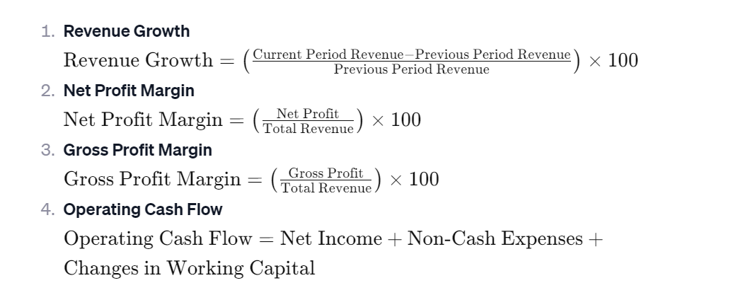 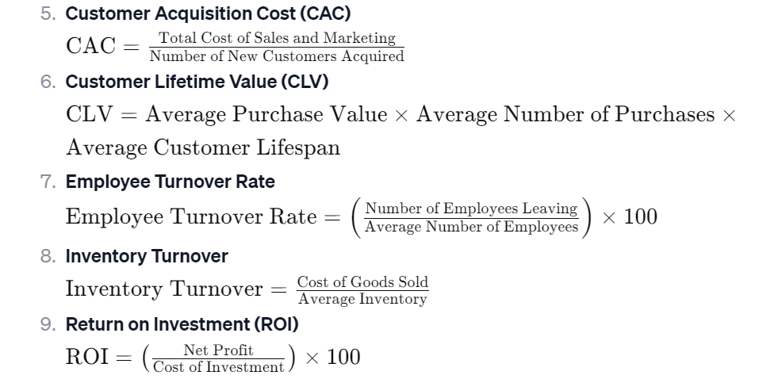 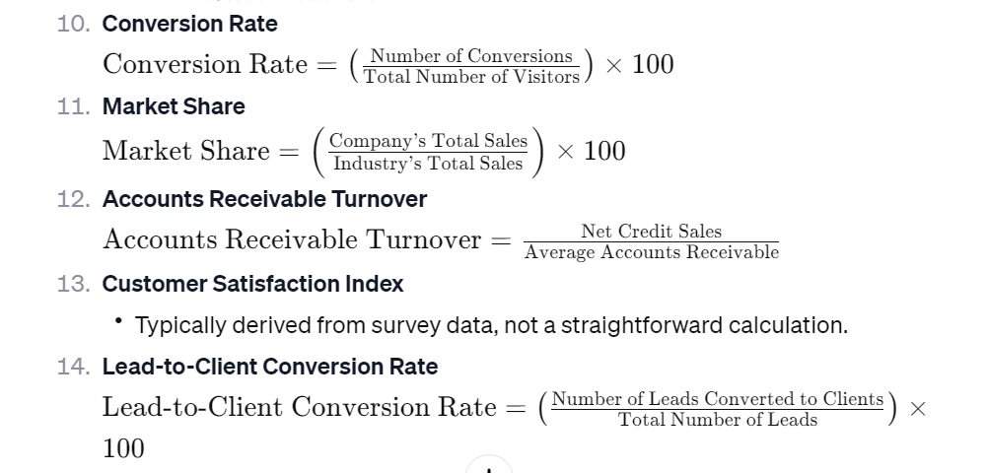 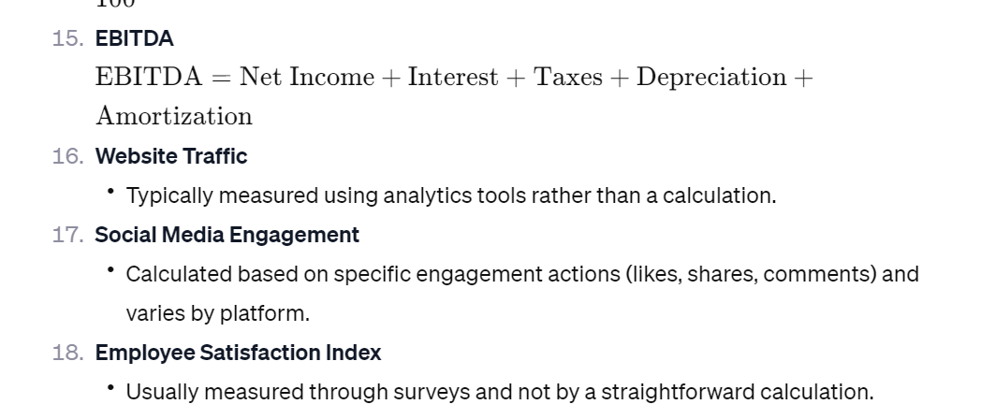 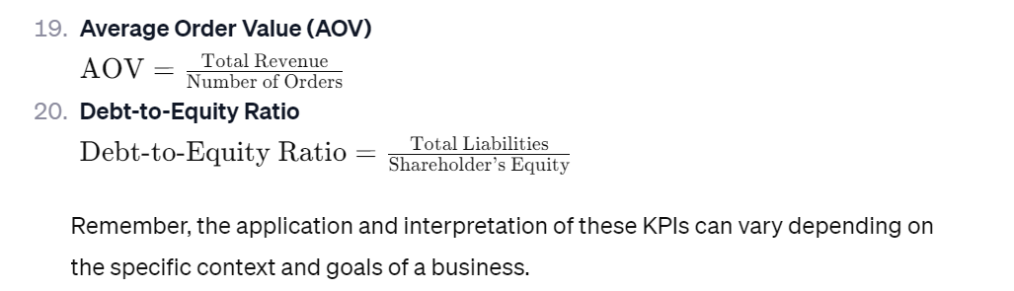
Absolutely, here are the formulas for calculating each of the 20 Key Performance Indicators (KPIs):
- Revenue Growth Revenue Growth=(Current Period Revenue−Previous Period RevenuePrevious Period Revenue)×100Revenue Growth=(Previous Period RevenueCurrent Period Revenue−Previous Period Revenue​)×100
- Net Profit Margin Net Profit Margin=(Net ProfitTotal Revenue)×100Net Profit Margin=(Total RevenueNet Profit​)×100
- Gross Profit Margin Gross Profit Margin=(Gross ProfitTotal Revenue)×100Gross Profit Margin=(Total RevenueGross Profit​)×100
- Operating Cash Flow Operating Cash Flow=Net Income+Non-Cash Expenses+Changes in Working CapitalOperating Cash Flow=Net Income+Non-Cash Expenses+Changes in Working Capital
- Customer Acquisition Cost (CAC) CAC=Total Cost of Sales and MarketingNumber of New Customers AcquiredCAC=Number of New Customers AcquiredTotal Cost of Sales and Marketing​
- Customer Lifetime Value (CLV) CLV=Average Purchase Value×Average Number of Purchases×Average Customer LifespanCLV=Average Purchase Value×Average Number of Purchases×Average Customer Lifespan
- Employee Turnover Rate Employee Turnover Rate=(Number of Employees LeavingAverage Number of Employees)×100Employee Turnover Rate=(Average Number of EmployeesNumber of Employees Leaving​)×100
- Inventory Turnover Inventory Turnover=Cost of Goods SoldAverage InventoryInventory Turnover=Average InventoryCost of Goods Sold​
- Return on Investment (ROI) ROI=(Net ProfitCost of Investment)×100ROI=(Cost of InvestmentNet Profit​)×100
- Conversion Rate Conversion Rate=(Number of ConversionsTotal Number of Visitors)×100Conversion Rate=(Total Number of VisitorsNumber of Conversions​)×100
- Market Share Market Share=(Company’s Total SalesIndustry’s Total Sales)×100Market Share=(Industry’s Total SalesCompany’s Total Sales​)×100
- Accounts Receivable Turnover Accounts Receivable Turnover=Net Credit SalesAverage Accounts ReceivableAccounts Receivable Turnover=Average Accounts ReceivableNet Credit Sales​
- Customer Satisfaction Index
  - Typically derived from survey data, not a straightforward calculation.
- Lead-to-Client Conversion Rate Lead-to-Client Conversion Rate=(Number of Leads Converted to ClientsTotal Number of Leads)×100Lead-to-Client Conversion Rate=(Total Number of LeadsNumber of Leads Converted to Clients​)×100
- EBITDA EBITDA=Net Income+Interest+Taxes+Depreciation+AmortizationEBITDA=Net Income+Interest+Taxes+Depreciation+Amortization
- Website Traffic
  - Typically measured using analytics tools rather than a calculation.
- Social Media Engagement
  - Calculated based on specific engagement actions (likes, shares, comments) and varies by platform.
- Employee Satisfaction Index
  - Usually measured through surveys and not by a straightforward calculation.
- Average Order Value (AOV) AOV=Total RevenueNumber of OrdersAOV=Number of OrdersTotal Revenue​
- Debt-to-Equity Ratio Debt-to-Equity Ratio=Total LiabilitiesShareholder’s EquityDebt-to-Equity Ratio=Shareholder’s EquityTotal Liabilities​
Remember, the application and interpretation of these KPIs can vary depending on the specific context and goals of a business.

- Aligning KPIs with Business Goals
  - For each KPI selected, define what success looks like (quantify where possible).
  - How do these KPIs align with your short-term and long-term business goals?
Section 4: Data Collection and Analysis
Content
- Methods of data collection.
- Basic principles of data analysis.
Questions/Exercises:
- Developing a Data Collection Plan
  - Identify data sources for each of your KPIs.
  - Outline a plan for how you will regularly collect, review, and analyze this data.
Section 5: Making Data-Driven Decisions
Content
- How to interpret analytics and make informed decisions.
- Avoiding common pitfalls in data interpretation.
Questions/Exercises:
- Case Study Analysis
  - Analyze a provided case study where a business uses data to make a strategic decision.
  - Identify key takeaways and how you might apply similar strategies in your business.
Section 6: Reflective Questions
- What challenges do you anticipate in implementing an effective analytics strategy?
- How can improved analytics and assessment change the way you manage your business?
Conclusion
- Summary of key learnings from Week 2.
- Encouragement to start integrating analytics into daily business practices.
Additional Resources
- List of tools, software, or platforms for data analytics.
- Recommended readings or courses to deepen understanding of business analytics and KPIs.

This workbook is designed to guide the small business owners through the fundamentals of business analytics and the effective use of KPIs. It should be provided in a format that allows for interactivity, ensuring that participants can actively engage with the content and exercises. The goal is to equip them with the knowledge and tools to start making more data-driven decisions in their businesses.

